Task 2:

Accepted collaborator request  
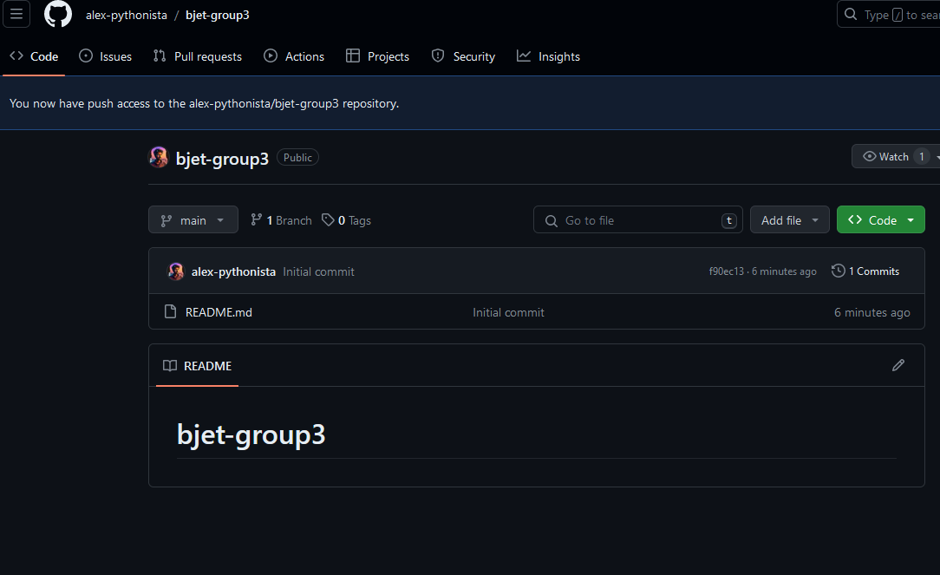

Cloning the project with ssh key  
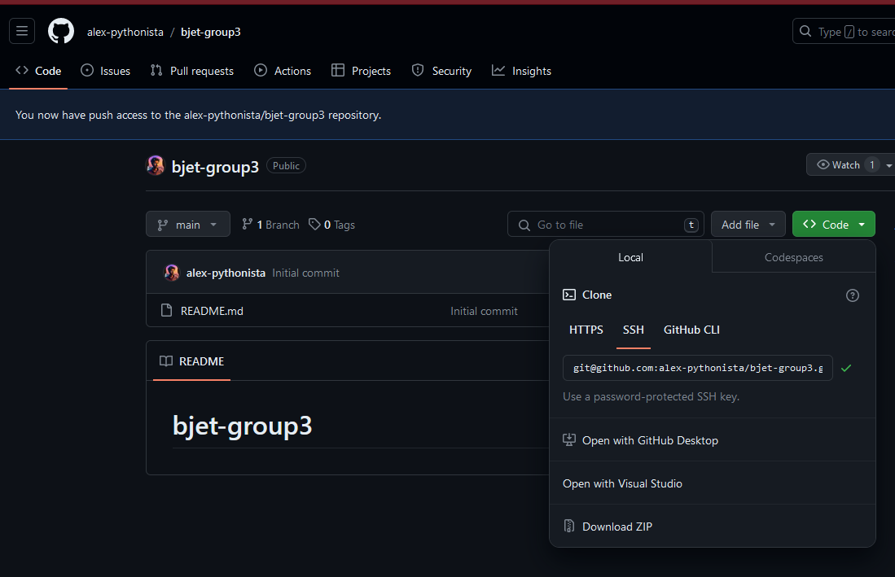

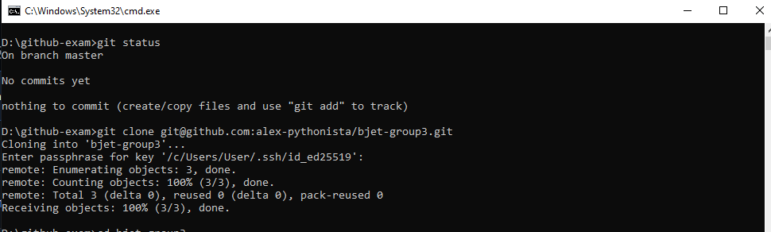

Creating new branch for my task2  


Preparing the “Development Technology” part

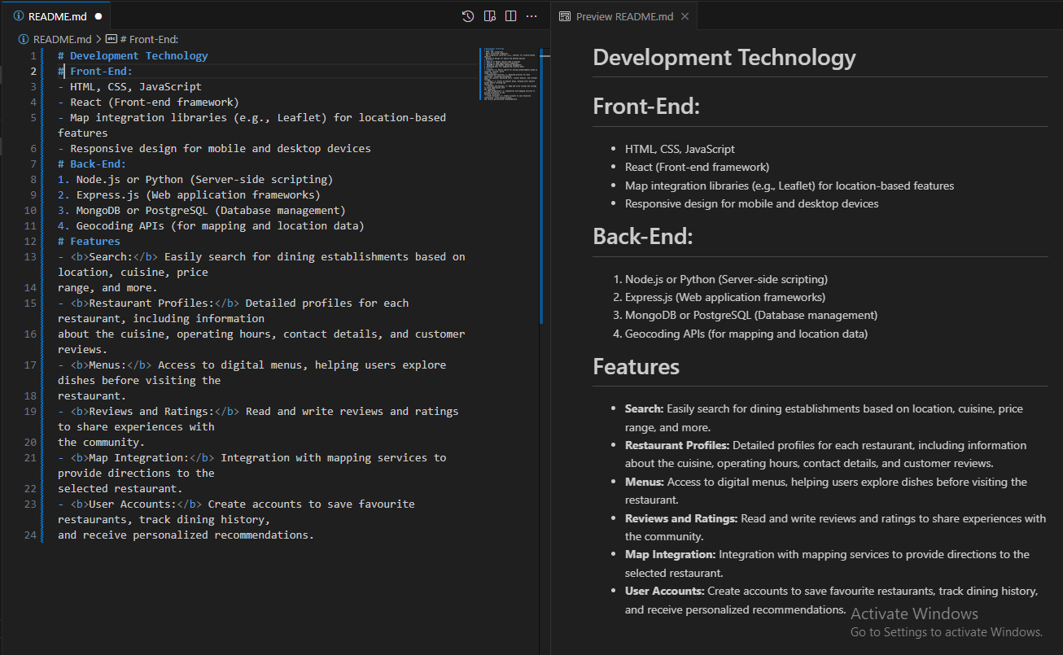

Task added and committed

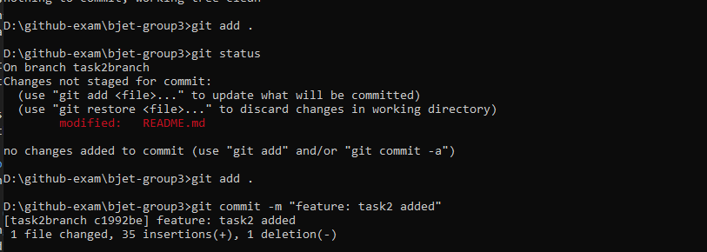

Merged to the development branch and got conflict

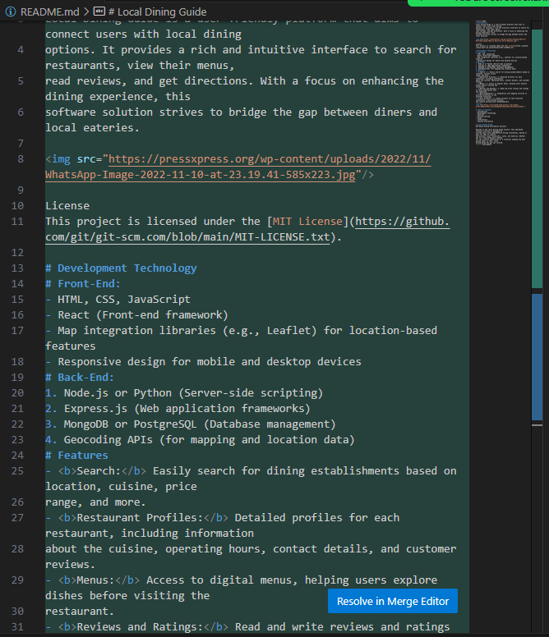

Merged and conflict resolved

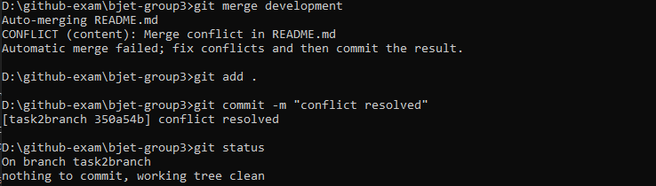

Pushed to the remote branch

